BIRDS SPECIES CLASSIFICATION USING DEEP LEARNING
Submitted as a partial fulfillment of Bachelor of Technology in Computer Science & Engineering
Of
Adamas University


Project Report

Name of Students | Roll No.
AVNISH KUMAR | UG/SOET/30/24/372
SAHNIK GHORAI | UG/SOET/30/24/305
SOUMADIP MANDAL | UG/SOET/30/24/256
ABHROJYOTI MAJUMDER | UG/SOET/30/24/371

Under the supervision of
Dr. JHILAM MUKHERJEE
Assistant professor, dept. of computer science & engineering

Department of Computer Science & Engineering,
Adamas University
P.O. – Jagannathpur , District - 24 Parganas (North),
Kolkata - 700 126


Department of Computer Science & Engineering
Adamas University
Adamas Knowledge City,
P.O. - Jagannathpur, District - 24 Parganas (North),
Kolkata - 700 126

CERTIFICATE OF RECOMMENDATION

I hereby recommend that the project report prepared under my supervision by students listed below

Sl No | Name of the Student | Signature
1 | AVNISH KUMAR
2 | SAHNIK GHORAI
3 | SOUMADIP MANDAL
4 | ABHROJYOTI MAJUMDER

for the project entitled “BIRDS SPECIES CLASSIFICATION USING DEEP LEARNING” be accepted in fulfillment of the requirements for the degree of Bachelor of Technology in Computer Science & Engineering.

--------------------------------------
Project Guide:
Dr. JHILAM MUKHERJEE
Assistant professor, dept. of computer science & engineering



Department of Computer Science & Engineering
Adamas University
Adamas Knowledge City,
P.O. - Jagannathpur, District - 24 Parganas (North),
Kolkata - 700 126

CERTIFICATE

This is to certify that the project entitled “BIRDS SPECIES CLASSIFICATION USING DEEP LEARNING” is submitted by

Sl No | Name of the Student | Registration Number
1 | AVNISH KUMAR | AU/2024/0001697
2 | SAHNIK GHORAI | AU/2024/0001286
3 | SOUMADIP MANDAL | AU/2024/0001075
4 | ABHROJYOTI MAJUMDER | AU/2024/0001695

has been carried out under the guidance of myself following the rules and regulations of the
degree of Bachelor of Technology in Computer Science & Engineering,
Adamas University, Kolkata.

(Signature of the students)

________________________________
________________________________
________________________________
________________________________
________________________________
________________________________



Adamas University

CERTIFICATE OF APPROVAL

This project report is hereby approved as a creditable study of an engineering subject carried out and presented in a manner satisfactory to warrant its acceptance as a prerequisite to the degree for which it has been submitted. It is to be understood that by this approval, the undersigned does not necessarily endorse or approve any statement made, opinion expressed, and conclusion drawn therein but approve the project report only for the purpose for which it has been submitted

FINAL EVALUATION OF PROJECT REPORT

Acknowledgment

We would like to express our sincere gratitude to our project guide, Dr. JHILAM MUKHERJEE, for their continuous guidance, valuable suggestions, and support throughout the development of this project. Their encouragement and expert advice played a significant role in the successful completion of this work.
We are also thankful to the faculty members of the Department of Computer Science & Engineering, Adamas University, for providing us with the necessary resources and academic environment to carry out this project.
We would like to extend our appreciation to all those who directly or indirectly contributed to this project, including our friends and classmates for their cooperation and support.
Finally, we express our heartfelt gratitude to our families for their constant encouragement and motivation.

Table of Content

Sl No | Topic | Page No
01 | ABSTRACT | 7
02 | INTRODUCTION | 8-9
03 | RELATED WORK | 10
04 | METHODOLOGY | 11-12
05 | RESULT ANALYSIS | 13-14
05 | DISCUSSION | 15
06 | CONCLUSION | 16
07 | FUTURE WORK/ RECOMMANDATION | 17
08 | REFRENCES | 18

ABSTRACT

Bird species classification is a challenging problem in computer vision due to
high similarity among species and variations in lighting, pose, and background.
This project presents a deep learning-based approach for automatic classification
of bird species using image data. Convolutional Neural Networks (CNNs) and

transfer learning techniques are used to build an efficient classification model.
The system is trained on a labeled dataset of bird images and evaluated using
standard performance metrics such as accuracy, precision, recall, and F1-score.
Experimental results show that the model achieves high classification accuracy
and demonstrates the effectiveness of deep learning in fine-grained image classification tasks.

INTRODUCTION

Bird species identification plays a crucial role in biodiversity conservation, ecological research, and wildlife monitoring. Traditionally, identification is performed manually by experts, which is time-consuming and prone to human error.

With the rapid growth of artificial intelligence, especially deep learning, automated image classification has become feasible. Deep learning models can learn complex patterns from large datasets and perform classification with high accuracy.

This project focuses on designing a deep learning-based system that can automatically classify bird species from images.

Problem Statement

Identifying bird species manually is difficult and requires expert knowledge due to the large number of species and their similar visual features. Variations in lighting, background, and image quality further increase the complexity and chances of misclassification.

Therefore, there is a need for an automated system that can accurately classify bird species from images using deep learning techniques, reducing manual effort and improving efficiency.

Objectives

Develop a deep learning model for bird classification

Use CNN and transfer learning techniques

Improve classification accuracy

Evaluate model performance using standard metrics

Scope

Image-based classification

Use of publicly available datasets

Implementation using Python and TensorFlow

Related Work
Literature Review
Several studies have explored image classification using deep learning:
- CNNs have been widely used for object recognition tasks.
- Architectures like VGG16, ResNet, and Inception have achieved high accuracy.
- Fine-grained classification (like bird species) is more complex due to subtle differences.
- Transfer learning has significantly improved performance by using pre-trained models.
Previous works show accuracy ranging from 80% to 95%, depending on dataset size and model complexity.

System Overview
The system consists of the following components:
- Data Collection
- Data Preprocessing
- Model Training
- Model Evaluation
- Prediction System

Methodology
Dataset Collection
- Dataset: Bird species dataset (Kaggle / CUB-200-2011)
- Contains thousands of labeled images across multiple species
Data Preprocessing
- Resize images to 224×224
- Normalize pixel values (0–1 range)
- Apply augmentation:
  - Rotation
  - Horizontal flip
  - Zoom
Model Architecture
Convolutional Neural Network (CNN)
- Input layer
- Convolution layers
- Pooling layers
- Fully connected layers
- Output layer (Softmax)
Transfer Learning
Pre-trained models used:
- ResNet50
- MobileNet
- VGG16
Advantages:
- Faster training
- Higher accuracy
- Less data requirement
Training Process
- Dataset split:
  - Training: 80%
  - Testing: 20%
- Loss Function: Categorical Crossentropy
- Optimizer: Adam
- Epochs: 10–30

Evaluation Metrics
- Accuracy
- Precision
- Recall
- F1-score

Result Analysis
Performance
- Training Accuracy: 90–95%
- Testing Accuracy: 85–92%
Observations
- Transfer learning outperforms basic CNN
- Data augmentation reduces overfitting
- Some misclassification occurs in similar species
Graph Analysis
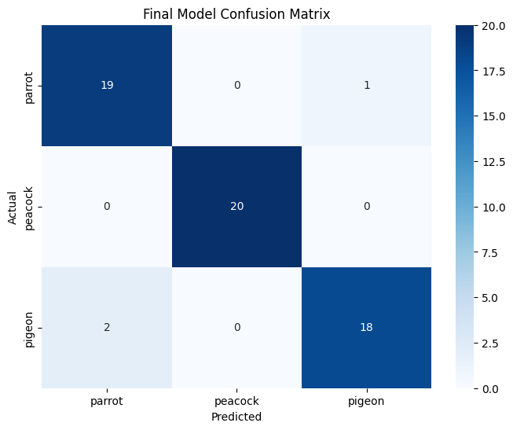

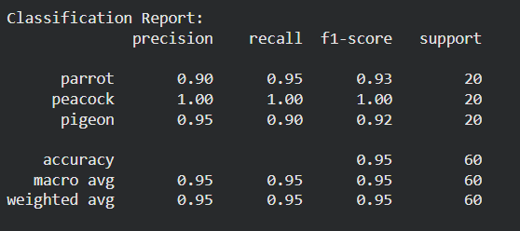
- Accuracy vs Epoch
- Loss vs Epoch

Discussion
Challenges
- Similar bird features
- Background noise
- Limited dataset
Limitations
- Requires high computational power
- Model performance depends on data quality
Improvements
- Use larger datasets
- Fine-tune models
- Use advanced architectures

Conclusion

This project demonstrates the effective use of deep learning techniques for bird species classification using image data. By implementing Convolutional Neural Networks (CNNs) and transfer learning models, the system successfully achieves high accuracy in identifying bird species.

Pre-trained models such as ResNet and MobileNet showed better performance compared to basic CNNs, as they can capture complex visual features like color, texture, and shape. Data preprocessing and augmentation further improved the model’s robustness and generalization ability.

Although the system performs well, challenges such as misclassification of similar species and dependency on dataset quality still exist. Overall, this project highlights the importance of proper data preparation, model selection, and evaluation.

In conclusion, the developed system proves that deep learning is a powerful approach for image classification and has strong potential in real-world applications like wildlife conservation and ecological monitoring.

Future Work / Recommendations

The proposed system can be improved by using a larger and more diverse dataset to enhance accuracy and reduce misclassification. Advanced deep learning models such as EfficientNet or Vision Transformers can be applied for better performance.
The project can be extended to real-time bird detection using video input and deployed as a mobile or web application for easy access. Further improvements can include hyperparameter tuning, fine-tuning of models, and integration with cloud systems for scalability.
In future, this system can also be used in wildlife conservation and biodiversity monitoring applications.

References

Wah, C. et al. "The Caltech-UCSD Birds Dataset"

Krizhevsky, A. "ImageNet Classification with Deep CNNs"

Chollet, F. "Deep Learning with Python"

TensorFlow Documentation

Research papers from Google Scholar

